 |  | Project Design Phase-II
 |  | Technology Stack (Architecture & Stack)
 | Date |  | 16th October 2022
 | Team ID |  | PNT2022TMID31229
 | Project Name |  | Project –Statistical Machine Learning
 |  |  | Approaches to liver disease prediction
 | Maximum Marks |  | 4 Marks
Technical Architecture:
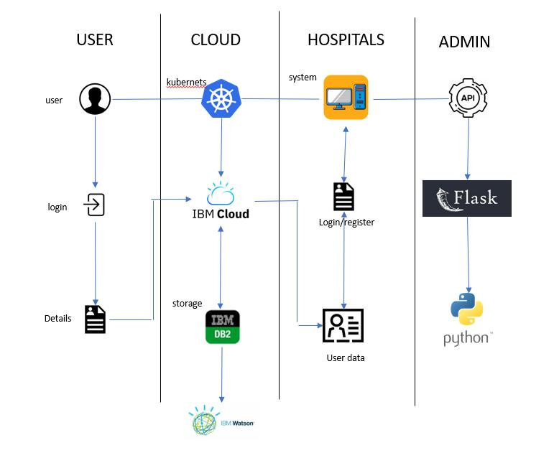

Table-1 : Components & Technologies:

S No | Component | Description | Technology
1. | User Interface | User access to the application through the | HTML
 |  | Mobile application.
2. | Application Logic-1 | Creating an application interface | Python & Flask
3. | Application Logic-2 | Creating an AI assistant that gives medical services | IBM Watson Assistance
 |  | To the user.
6. | File Storage | Files are stored in the local storage and stored in the | IBM Block Storage or Other Storage
 |  | Cloud. | Service or Local File system
7. | External API-1 | Use this REST API to manage locations. Get | IBM Location REST API
 |  | All locations. URI, /admin/resources/locations.
 |  | Method, GET.
8. | Deep Learning Model | Creating an algorithm to calculate case information | Object Recognition Model, etc.
 |  | Provides by the hospitals.
9. | Infrastructure (Cloud) | IBM Cloud App Configuration is a centralized | IBM Cloud Foundry &K ubernetes
 |  | feature-management and configuration service
 |  | on IBM Cloud.

Table 2: Application Characteristics:

S No | Characteristics | Description | Technology
1. | Open-Source Frameworks | There are no open-source frameworks in this | Python
 |  | Application.
2. | Security Implementations | Block chain technology is used for Security | Block chain
 |  | implementation its private framework protects all
 |  | Data.
3. | Scalable Architecture | Users are provided with medical services online and | IBM Cloud
 |  | giving awareness to people by giving therapeutic
 |  | medicines and monitoring user movements in
 |  | Pandemic zones and alerts before they are affected.
4. | Availability | Medicinal Recommendations, Test kits, Doctor | IBM Watson Assistant
 |  | suggestions, and Updated Contaminated zones are
 |  | Available in applications.
5. | Performance | The geo-fencing algorithm is updated daily and | Geo fence
 |  | shows the day-to-day updates of the contaminated
 |  | Zones.

